



LAB MANUAL
DBMS

Disclaimer: The content is curated from online/offline resources and used for educational purpose only
BFS for Shortest Path in a Maze

Objective:
To understand and implement Breadth-First Search (BFS) to find the shortest path in a maze represented as a grid using Python.

Problem Statement:
Given a maze represented as a 2D grid of 0s and 1s:
- 0 represents a wall
- 1 represents a valid path
- Find the shortest path from the top-left (0, 0) to the bottom-right corner using BFS.

Equipment Required:
- A computer with:
  - Python 3.x installed
  - Jupyter Notebook (Anaconda or via pip install)
- Any code editor (optional)
- Internet (for further references)

Prerequisites:
- Python programming basics
- Understanding of BFS (Breadth-First Search)
- Knowledge of 2D arrays or matrices

Procedure:
Step 1: Define the Maze and Import Required Libraries
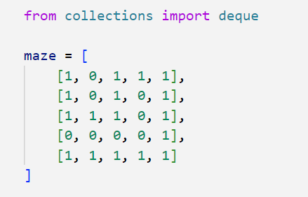

Step 2: Define BFS Function for Shortest Path Search

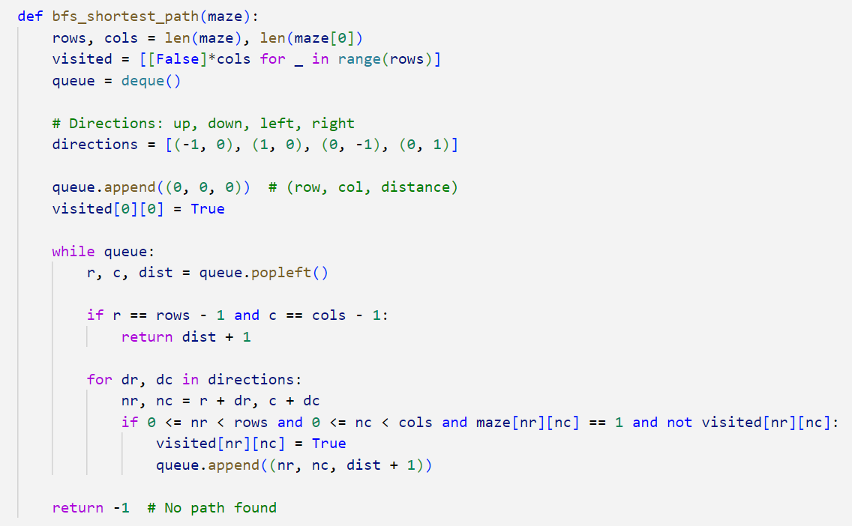

Step 3: Call the BFS Function and Display Result
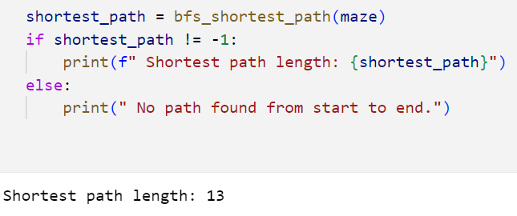

Conclusion
In this lab, we:
- Represented a maze as a 2D matrix
- Applied BFS to find the shortest path
- Understood how BFS explores level by level

